**Project Milestone 2 Part 1**

**Team EatNomz**

**Part 1a: Website Use Cases (10%)  (list at least 5 use cases of the website)**

Pre-Defined Partial Path

Checkout (Single Order)

* Navigates to the shopping cart
* Clicks on “pick up delivery date” text box and selects calendar date from pop-up graphic
* Clicks on “order quantity” text box and adjusts to desired number of servings
* Clicks on “order notes” text box and types in additional notes for deliverer
* Clicks the “checkout” button
* Enters email, name, shipping address, and phone number information into text boxes
* Enters discount code (if owned) and clicks “apply”
* Checks the information for correctness and clicks “continue to payment method”
* Enters in credit card information
* Clicks “place order”
* Waits for order to be delivered
* Receives order at the shipping address

**Use Cases (Ranked by Order of Importance)**

*Use Case: Briefly examines the website before placing an order*

* Goes to Nomz homepage
* Scrolls through the home page
* Selects product on homepage or goes directly to the buy page
* Checkout (Single Order)
* Exit

*Use Case: Goes directly to place a one-time order*

* Goes to Nomz homepage
* Navigates cursor directly to the “buy” button on the right
* Scrolls down page to view products
* Clicks on the product(s) of interest
* Scrolls down to view “add to cart” button
* Checkout (Single Order)
* Exit

*Use Case: Thoroughly examines the website before potentially placing an order*

* Goes to Nomz homepage
* Scrolls through the homepage and wants further insight
* Scrolls to the top of the page to inquire “about us”,  “how Nomz works”, and the “FAQ”
* After satisfaction with the information garnered, goes to the “buy” page to make a purchase
* Checkout (Single Order)
* Exit

*Use Case: Contact the business*

* Go to Nomz homepage
* Access “Contact Us” in the bottom of the page
* Fill out the contact form
* Exit

*Use Case: Goes directly to place a subscription order*

* Goes to Nomz homepage
* Navigates cursor directly to the “buy” button on the right
* Scrolls down page to view products
* Clicks on the product(s) of interest
* Scrolls down to select subscription options and click “complete subscription” button
* Enter personal information in reurringcheckout.com
* Exit

*Use Case: Manage Subscription*

* Goes to Nomz homepage
* Click “sign in” button in the navigation bar
* “Sign in” in the upcoming window
* Click “Manage Subscription” to manage subscriptions
* Manage Subscription in recurringcheckout.com
* Exit

*Use Case: Leave a product review*

* Goes to Nomz homepage
* Navigates cursor directly to the “buy” button on the right
* Scrolls down page to view products
* Clicks on the product(s) of interest
* Clicks on “write a review” option on the product page.
* Complete the form
* Exit

*Use Case: Further engage Nomz through the blog*

* Goes to Nomz homepage
* Click “Blog” button in the navigation bar
* Read the posts
* Click “comment” link to create new comment for the post
* Exit

**Persona and Path Importance Analysis**

|  |  |  |  |  |
| --- | --- | --- | --- | --- |
| **Persona** | **Current Population (Projected with Google Analytics)** | **Potential Sources of Access** | **Most Important Use Case(s)** | **Conversion Rate** |
| Skeptical New Customer | High | Search Engine, Secondary Referral | Thoroughly examines the website before potentially placing an order | Low |
| Trusting New Customer | Medium | Primary and Secondary Referral | Briefly examines the website before placing an order | Medium |
| Returning Customer | Medium | Direct Link | Goes directly to place an one-time order | High |
| Community Engager | Very Low | Social Media, Direct Access | Further engage Nomz through the blog | High |
| Frustrated Customer | Very Low | Direct Link | Contact the business | Very Low |

**Part 1b: Functional Design – Page Load Time Analysis (10%)**

**Preliminary Load Time Data**

|  |  |
| --- | --- |
| Performance grade out of 100 | 67 |
| Mean | 1.89 |
| SD | 0.43 |

|  |  |
| --- | --- |
| Date / Time | Load Time |
| 2/16/16 7:00 PM | 1.51 |
| 2/16/16 8:00 PM | 1.89 |
| 2/16/16 9:00 PM | 1.89 |
| 2/16/16 10:00 PM | 1.66 |
| 2/16/16 11:00 PM | 2.12 |
| 2/17/16 12:00 AM | 1.78 |
| 2/17/16 1:00 AM | 2.12 |
| 2/17/16 2:00 AM | 2.18 |
| 2/17/16 3:00 AM | 1.9 |
| 2/17/16 4:00 AM | 1.87 |
| 2/17/16 5:00 AM | 2.59 |
| 2/17/16 6:00 AM | 1.93 |
| 2/17/16 7:00 AM | 2.07 |
| 2/17/16 8:00 AM | 1.85 |
| 2/17/16 9:00 AM | 1.62 |
| 2/17/16 10:00 AM | 1.92 |
| 2/17/16 11:00 AM | 2.89 |
| 2/17/16 12:00 PM | 1.8 |
| 2/17/16 1:00 PM | 2.05 |
| 2/17/16 2:00 PM | 1.82 |
| 2/17/16 3:00 PM | 2.18 |
| 2/17/16 4:00 PM | 2.34 |
| 2/17/16 5:00 PM | 1.8 |
| 2/17/16 6:00 PM | 1.86 |
| 2/17/16 7:00 PM | 1.69 |
| 2/17/16 8:00 PM | 1.98 |
| 2/17/16 9:00 PM | 2.83 |
| 2/17/16 10:00 PM | 1.75 |
| 2/17/16 11:00 PM | 1.93 |
| 2/18/16 12:00 AM | 2.03 |
| 2/18/16 1:00 AM | 2.16 |
| 2/18/16 2:00 AM | 2.58 |
| 2/18/16 3:00 AM | 1.75 |
| 2/18/16 4:00 AM | 1.94 |
| 2/18/16 5:00 AM | 1.67 |
| 2/18/16 6:00 AM | 2.03 |
| 2/18/16 7:00 AM | 2.66 |
| 2/18/16 8:00 AM | 1.58 |
| 2/18/16 9:00 AM | 1.37 |
| 2/18/16 10:00 AM | 1.02 |
| 2/18/16 11:00 AM | 1.3 |
| 2/18/16 12:00 PM | 2.27 |
| 2/18/16 1:00 PM | 1.1 |
| 2/18/16 2:00 PM | 1.15 |
| 2/18/16 3:00 PM | 1.41 |
| 2/18/16 4:00 PM | 1.08 |
| 2/18/16 5:00 PM | 1.88 |
| 2/18/16 6:00 PM | 1.26 |
| 2/18/16 7:00 PM | 1.55 |
| 2/18/16 8:00 PM | 1.91 |
| 2/18/16 9:00 PM | 1.93 |
| 2/18/16 10:00 PM | 2.89 |
| 2/18/16 11:00 PM | 1.55 |
| 2/19/16 12:00 AM | 1.54 |
| 2/19/16 1:00 AM | 2.12 |
| 2/19/16 2:00 AM | 2.11 |
| 2/19/16 3:00 AM | 2.48 |
| 2/19/16 4:00 AM | 1.59 |
| 2/19/16 5:00 AM | 1.38 |
| 2/19/16 6:00 AM | 1.56 |
| 2/19/16 7:00 AM | 2.31 |
| 2/19/16 8:00 AM | 2.19 |

**Daily Average Load Times**

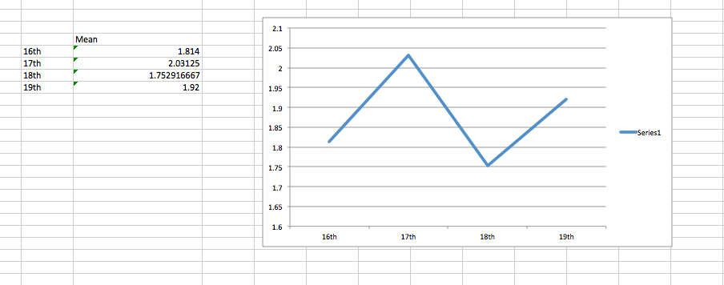

**Hourly Load Times**

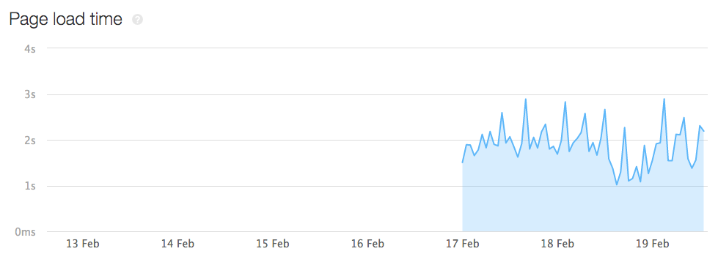

**Part 1c: Visual Design – Browser Display Test (10%)**

Table 1: Analysis of Visual Design Elements using Different Browser/Devices

|  |  |  |  |  |  |
| --- | --- | --- | --- | --- | --- |
| Page | Chrome | Internet Explore | FireFox | iOS | Android |
| Home Page | The banner disappears then reappears as you scroll down  The “buy” link button switches positions on the banner when navigating from page to page  Product image does not scroll along with product description and reviews  The drop-down arrows for “subscribe” is overlapping with numbers and the week text. “See details” link does not appear on one line[1]  The top margin for the home page is different than all other pages | The banner disappears then reappears as you scroll down  The “buy” link button switches positions on the banner when navigating from page to page  Product image does not scroll along with product description and reviews  The drop-down arrows for “subscribe” is overlapping with numbers and the week text.[1]  The top margin for the home page is different than all other pages | The banner disappears then reappears as you scroll down  Product image does not scroll along with product description and reviews  The drop-down arrows for “subscribe” is overlapping with numbers and the week text. “See details” link does not appear on one line[1]  The top margin for the home page is different than all other pages | Clear and navigable. Menu options on the far left and must be clicked to open up.  The “buy” link button does not show up on the top banner | The “buy” link button does not show up on the top banner  Product images do not load as quickly as compared to other browsers |
| Buy Page | The “buy” link button switches positions on the banner when navigating from page to page  When you click on “Products” in the “Home > Products > Page 1 of 1” hierarchy, it keeps you on the “Page 1 of 1” page. [2] | The “buy” link button switches positions on the banner when navigating from page to page  When you click on “Products” in the “Home > Products > Page 1 of 1” hierarchy, it keeps you on the “Page 1 of 1” page. [2] | Text (as headers and under products) shrinks to smaller font size  When you click on “Products” in the “Home > Products > Page 1 of 1” hierarchy, it keeps you on the “Page 1 of 1” page. [2] | The “buy” link button does not show up on the top banner--must click into the menu.  From there, the buy page displays  products clearly  When you click on “Products” in the “Home > Products > Page 1 of 1” hierarchy, it keeps you on the “Page 1 of 1” page. [2] | The “buy” link button does not show up on the top banner  Product images do not load as quickly as compared to other browsers  When you click on “Products” in the “Home > Products > Page 1 of 1” hierarchy, it keeps you on the “Page 1 of 1” page. [2] |
| Individual Product pages | The “buy” link button switches positions on the banner when navigating from page to page  Product image does not scroll along with product description and reviews  “Add noodles?” has a default selection, while “Is this a gift?” does not [3] | The “buy” link button switches positions on the banner when navigating from page to page  Product image does not scroll along with product description and reviews  “Add noodles?” has a default selection, while “Is this a gift?” does not [3] | “Add noodles?” has a default selection, while “Is this a gift?” does not [3] | Only available when  go to “buy” link  The product image and description as well as the reviews are oriented correctly | Product images do not load as quickly as compared to other browsers |
| Blog | The “buy” link button switches positions on the banner when navigating from page to page | The “buy” link button switches positions on the banner when navigating from page to page | News categories only has one category to select from [4]  The text for the Nomz label picture is too small to read [5] | Similar to the desktop, the blog is easy to scroll through | The “buy” link button does not show up on the top banner |
| About Us | The “buy” link button switches positions on the banner when navigating from page to page  The color scheme at the top of the page makes reading the words in top banner difficult [6] | The “buy” link button switches positions on the banner when navigating from page to page  The color scheme at the top of the page makes reading the words in top banner difficult [6] | The color scheme at the top of the page makes reading the words in top banner difficult [6]  The margins for the text under “Our Story” is not aligned with the right margins for the text below “Our Team” [7] | Clear and easy to navigate and scroll through | The “buy” link button does not show up on the top banner |

*Concluding notes:

* The website is mobile optimized but not optimized for desktop browsers.
* The website presents many different problems across different desktop browsers.

[1]

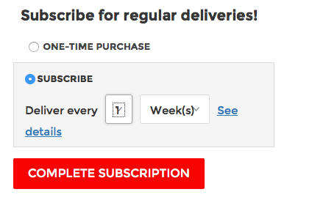

[2]

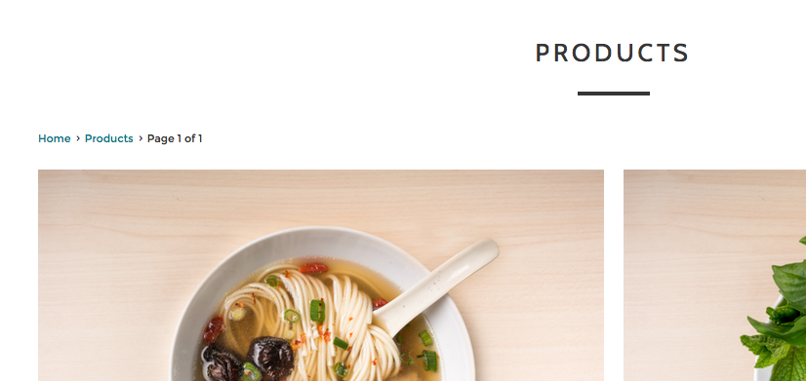

[3]

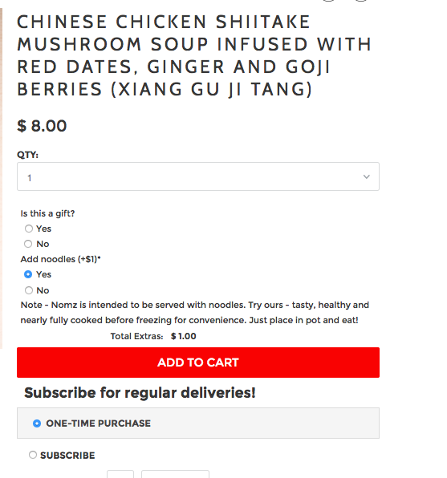

[4]

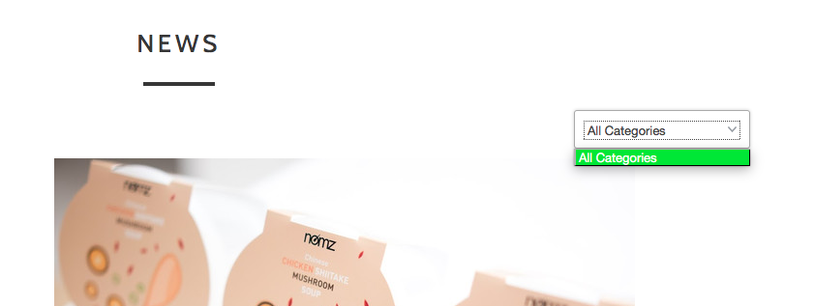

[5]

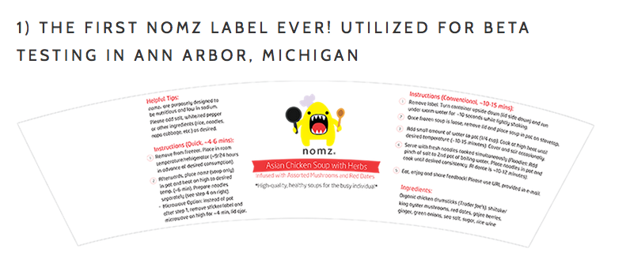

[6]

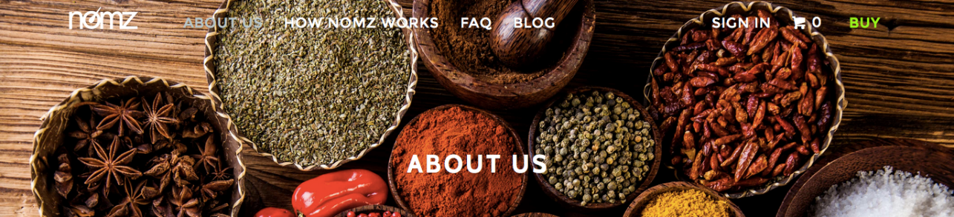

[7]

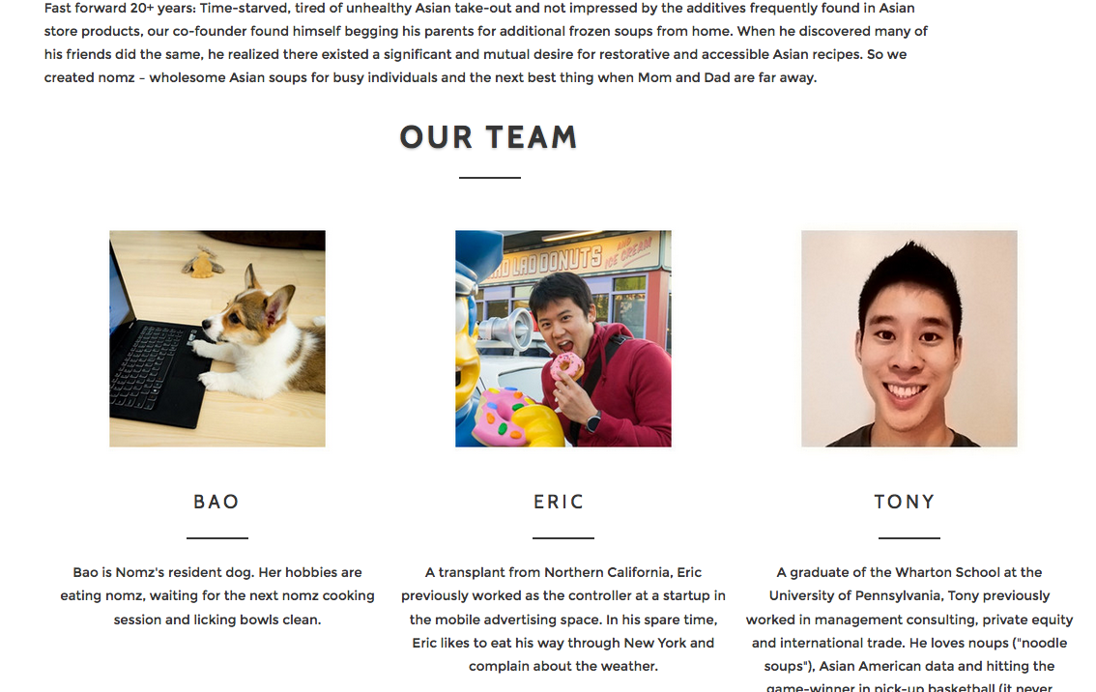

**Part 1d: Information Design – Contact, Location, and About Us Information (10%)**

|  |  |  |  |
| --- | --- | --- | --- |
| **Page** | **Information- Text** | **Information- Images** | **Status** |
| Home | Business Overview and Problem Statement  Business Process  Product Description | Product Logo  Cover Page Photo (Well Designed)  Beautified Product Display  Icons to Supplement Business Process  Cooking Process  Product Display | Up to Date. |
| About | Business Story  Management Team | Management Team Picture | Up to Date |
| Blog | Business Development Process  Business Update  Information Regarding how the business came to be.  Current Marketing Efforts  Survey Results | Product Prototype Images  Competitor Product Images  Mascot Pictures  Visualized Survey Results | Out of Date, needs to be updated |
| FAQ | Business Overview  Business Process Descriptions  Ingredient Sourcing Information | Cooking Processes | Up to Date |
| How Nomz Works | Business Processes  Cooking Instructions | Images of raw materials | Up to Date |
| Shopping Cart (When filled) | Shipping Information  Order Form  Cart Information  Product Price | Product Image | Up to Date |
| Buy (Product listing) | Product Name  Product Price | Product Image | Make testimonials visible before clicking on the product |

**Part 1e: Initial DUX Improvement Suggestions (20%)**

**Functional Design:**

1. Include less on the home page. Take the products and buying options out of the home page completely and make visitors go into the buy page to make purchases. Perhaps stop the homepage after the third image (see Exhibit 1e.1) and add a “Shop now” button at the bottom of the homepage.
2. On the “Shopping Cart” page, instead of leaving the pick a delivery date field blank, suggest a default delivery date. This could decrease the number of clicks to purchase. (see Exhibit 1e.2)
3. Either remove the “All Categories” button on the blog, or segment the material into multiple categories such that the button selects from these categories (informational design) (Exhibit [4] from Part 1.c above)
4. Provide an “Add to Cart” interactive element every time product information is displayed. (Exhibit 1e.3)
5. As more products are released, perhaps include a search feature on the top banner of the website.

**Visual Design:**

1. Increase the font size and slightly decrease the line spacing for all text on the website.
2. Place emphasis on selected information by either increasing the font size or having a different font color for call to action links. (Exhibit 1e.4)
3. On the blog page, improve layout by removing the left-most column that displays category (as this displays too much white space) and nest the category titles within the blog post. (Exhibit 1e.5)
4. On the home page, keep the “Blog” button (and all other buttons) on the same line as the logo. If the user is zoomed in too far on the page, such that the “Blog” button cannot be displayed on the same line as the logo, then move all elements in the top margin into a navigation menu in the top-left corner of the page.
5. Make sure the top banner has the same margins on all pages to increase consistency.
6. Add a translucent background to the top banner on all pages similar to that on the Blog page (Exhibit 1e.6). This will increase visibility and consistency throughout pages
7. On the “about us” page, align the right and left margins of all of the text segments, so that the layout is consistent on the webpage. (Exhibit [8] from Part 1.c above)
8. Expand the width of the “deliver every” component on the product page, so that the downward arrow does not overlap with the button text. (Exhibit [1] from Part 1.c above)

**Information Design:**

1. Include a video on the homepage to explain the business’ key value proposition.
2. The product image should scroll along with the product description and reviews.
3. Expand the width of the text of the product description so that the user does not have to scroll down as much. This reduces the amount of unnecessary white space.
4. Shorten the “ingredients” section into a series of bullet points.
5. Make “Contact Us” page more accessible. Currently, you have to scroll down a full page to get to the link to the page.
6. The product name is too long; there is a lack of use of “benefit-oriented headlines” (ie: too many words for product information; see Exhibit 1e.7). Shorten the product name and perhaps have mouse-over-text information over the name of the product.
7. Include a phone number the customers can call. We believe that a phone number information is crucial for a delivery service.

**Exhibit 1e.1: Suggestion of how the homepage should end**

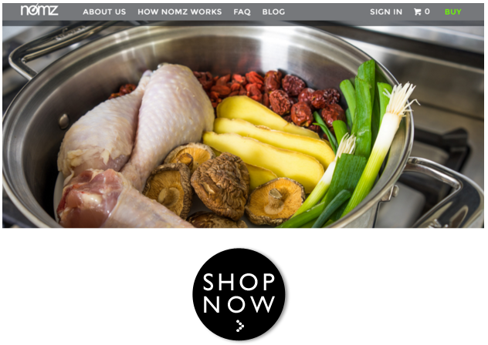

**Exhibit 1e.2: Suggestion on delivery date field at shopping cart page**

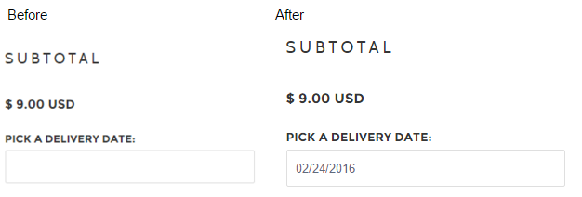

**Exhibit 1e.3 Add a purchasing option every time product is displayed.**

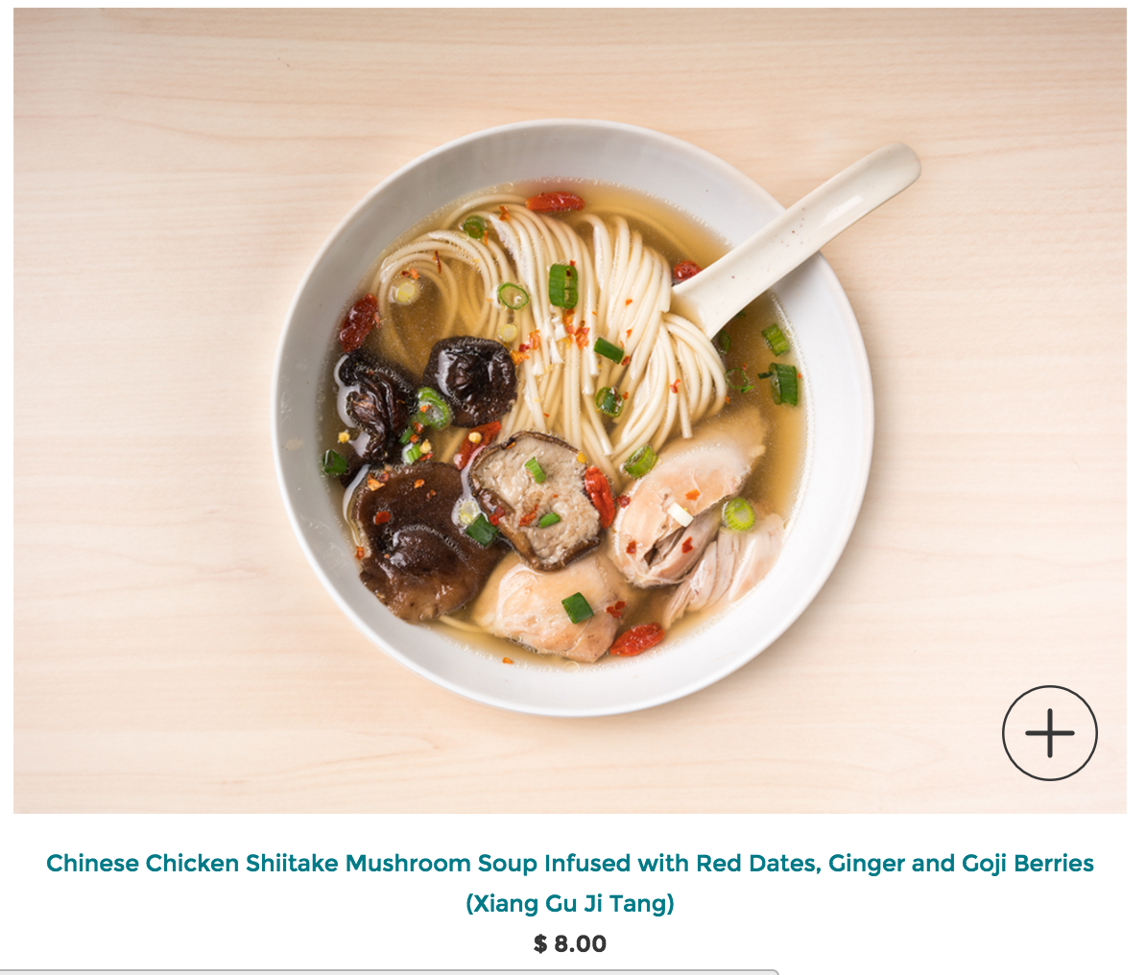



**Exhibit 1e.4 Have a different font color for call to action links like the “BUY” link**

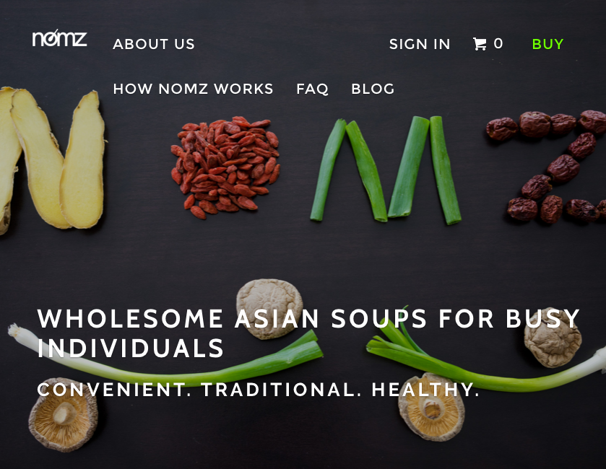

**Exhibit 1e.5 Reduce the width of the left margin on the blog page**

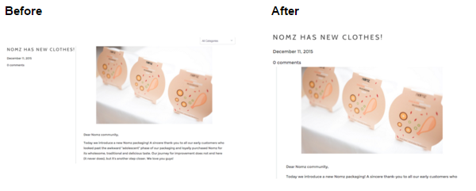

**Exhibit 1e.6 Add a translucent background for the top banner to all pages**  
  


**Exhibit 1e.7 Shorten product name and add a mouse-over text description.**

